Fly Fishing 101 PDF Guide
I am sharing with you a beta version of the Fly Fishing 101 PDF Guide. Beta version right? What the heck is that?
Here’s the deal - I’m still working on it so you will get the beginning of it here and if you like it I will continue adding more to it.
You can send me an email anytime at dave@wetflyswing.com to let me know how it’s going.
Ok, let’s get into this thing.
I would really, really, really love to hear back from you!
It would be great to hear what your biggest struggle is with fly fishing so I can help guide this pdf guide.

Table of Contents:
Chapter 1: Gear to Get Started (page 3)
Chapter 2: How to Fly Cast (Page 12)
Chapter 3: Wet Fly Fishing (Page 22)
Chapter 4: Nymph Fishing (not complete yet) Send me an email to find out when it will be ready.
Chapter 5: Dry Fly Fishing
Chapter 6: Reading Water

Chapter 1. Fly Fishing 101 - Gear to Get Started
Have you been wondering what it would take to get started fly fishing. To learn the Fly Fishing Basics so you can go connect with nature and reel in a big one?
Maybe you’re thinking it will just cost too much money to start a new thing? Looking at the price tags on some of this gear and wondering – WTF!
That’s right (what the F#*@ck)
Some of this stuff is crazy expensive, but you don’t need to go there when getting started.
Don’t let anyone BS you and tell you that you need to spend a lot of money ($$) on fly fishing gear when first getting started.
YOU DON’T.
I cover Fly Fishing Basics when getting started as a newbie to fly fishing below.
(by the way, the photo above is yours truly as a young buck. You’ve got to love the glasses right?)
You can get started for a very reasonable amount of money so you won’t break the bank. I’ll also cover the basics so you know what you need to catch your first fish on a fly.
I started fly fishing when I was a young lad and quickly looked like I walked out of an Orvis Catalog. You don’t have to look like this.
My dad owned a fly shop so I loved getting every bit of new gear that was out there.
You don’t need to.
There are though, a few fly fishing basics you need to get started that I’ll cover below.

Fly Fishing Basics – What You Need

Fly Rod
You can get one rod to start out that will fish for a number of species. A 8.5 foot rod in a 5 weight will do just fine for most situations. Orvis covers more details on choosing a fly rod here.
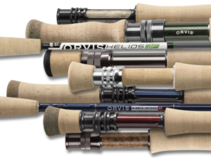
You can go longer or shorter on the rod length and heavier or lighter on the rod weight. It all depends on the type of fishing you are doing but for trout an 8.5′ to 9′ rod in a 4 to 6 weight rod is usually good.
The larger the weight of the rod, the bigger fish it will handle. So, a 4 weight rod is for small fish and an 8 weight rod is for large fish.

Fly Line
The next most important thing is to balance your fly line with the fly rod. This is another basics thing and in most cases you choose a line that is the same weight as the rod. So, if you have a 5 weight rod, you need a 5 weight line.
There are also different types of fly lines, including weight forward, double taper, etc but I won’t go into detail here. A weight forward 5 weight line will do just fine when getting started for trout.
Rio covers some of the basics of their trout lines here (video):

Fly Reel
You need a fly reel to hold your fly line, backing and leader.
One of the main features of a fly reel is the drag which controls how easy the fish can strip off line when running on you.
On larger species the drag is a critical component but for trout and getting started it’s not super critical.
You also want to find a reel that balances well for the rod you use. Basically you don’t want to get a super heavy reel if you are using a lightweight rod. This video describes a few more details about choosing a reel:

Backing
You can’t forget about backing especially for some or our west coast rivers where those bigger trout have plenty of room to spool you out. Typically as long as you have at least 100 yards on your reel you are good.
A bigger real will allow for more backing. This link gives a little more info on backing. Purchase your reel first and then go to the manufacturers website to find out what they recommend.

Leader
Buying a leader and tippet is another piece of your terminal tackle that doesn’t have to be difficult.
The tippet is a shorter section that attaches the fly to your leader. It’s typical that as you change flies and your tippet gets shorter you will eventually have to add a new leader.
(Tippet length are usually 12 to 18″ long)
Typically a 7.5 to 9′ long leader in a 5x range will work fine for trout.
The X part of the equation describes how thick the leader is. The higher the number before the X the lighter and thinner the leader is. So, a 7x leader might be appropriate for a size 18 fly (I’ll cover this next).
And a 3x leader might be good size #6 flies. A 4-6x leader with a tippet is usually a good place to start for trout fishing.
Back to tippet:
remember, the tippet part of the leader is the end of the leader that attaches to fly. This sizing also follows the same X details described above and covered here by Orvis:
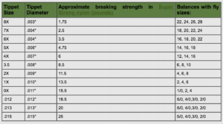
Ok, cool. Now you’ve got your rod, reel, line, backing and leader. Maybe you don’t have it yet but you have a good feel for what you need.
I’ll get into where to get your stuff in more detail on another post. But, I did want to leave you with one link to a blog post that covers a good selection of all of the gear I covered above.

Flies
Let’s finish off with the final touch on fly selection. To be honest, other than presentation, fly selection can be the most challenging thing to figure out because you can go very deep on this subject.
Every heard of entomology?
I could write all day on fly selection and orders of insects, etc. To keep it very simple there are 3 main types of flies you can use. Dry flies are on the surface, wet flies are in the surface and nymphs are below the surface.
There are other types but let’s keep it simple for now. If you want to learn more about flies, entomology or fly tying you can click this link and send me an email.
Before you choose a fly you need to find out where you are fishing. After you know where you are going you can do a little more research on what is hatching this time of year.
But to make it easy here take a look at this link:
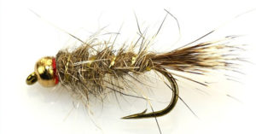
These guys do a really good job in their blog post to keep it simple for some of the best all around flies for trout.
If you are interested in learning to tie your own flies you can send me an email or check out the Fly Tying Mentor here.
This is an online training course I run that includes fly tying material deliveries to your doorstep along with some other awesome extras.

Other Fly Fishing Basics
You will need a bunch of little cool things eventually like forceps, clippers, fly boxes, a vest, a hat, polarized glasses, waders, wading boots, etc, etc.
Maybe we’ll leave that for a later post. If you get the stuff we talk about above you will be able to catch your first fish.
When you do please check back in and share a photo.

Conclusion
Pretty simple right? Ok, maybe there is a little to it but I don’t want you to get overwhelemed. I think people to tend to make things harder at the start.
Take it one step at a time and you’ll be good. Find a good rod, reel and line to start. Then find a few good flies for the nearest river and get out there.
The next thing you might need is a little casting lesson so stay tuned for the next article when I’ll walk you through the basics for trout.
But before I leave you take a look at this link which gives you some super cool tips on fly casting:
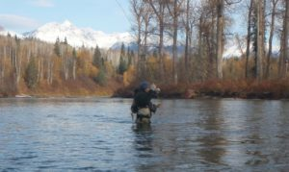
These might be a little more advanced than your typical beginner post, but will help you for sure either now or later!

Chapter 2: How to Cast a Fly Rod

Are you totally new to fly fishing and wondering how someone could cast a fly line 100’s of feet? Maybe you’ve been out on the river only to “snap” off a bunch of flies? Or you just have no idea how to cast a fly rod and need a little help?
Follow along below and I’ll provide some quick tips and links to awesome resources on this topic.
Sound good? If you have a little experience and need a little more advanced content on fly casting take a look at this link: 9 tips on Increased Fly Casting.

How to Cast a Fly Rod – 7 Steps

1. Fly Fishing Gear
The first step to the fly cast is making sure you have a balanced outfit. Take a look here to see a few resources to make sure you find the right gear.
The Reel weight, line weight and rod weight should all be balanced in order to make an effective fly cast. Start with a balanced outfit and your life will be much easier as you get into this.

2. Where to Practice Casting
The best place to practice casting is on the water so if you can find a nice calm stream or lake nearby go there.
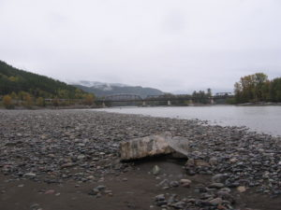
If you only have a grassy yard, you can still practice there. You can tie a small piece of yarn in place of a fly on the end of your leader to help simulate the fly. The yarn will stick to the grass a bit and help to load the rod.
There are a few basic knots you should learn for fly fishing but the yarn knot can just be as basic as you need to get it done.

3. How to hold the fly rod
There are numerous ways to hold a fly rod and at the end of the day it comes down to what feels comfortable for you. The most common grib for average length casts is the thumb on top of the cork.
One important point that Pete makes in the video below is, regardless of the grip you choose, to use a relaxed grip and don’d grip the rod too hard.
Take a look at this video: How to Grip a Fly Rod
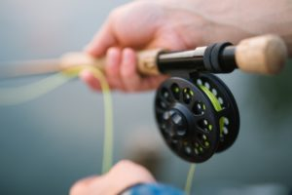

4. How to hold the line
When starting out casting a fly rod I recommend that you start with a very short amount of line (20′ range) and keep all of the extra line on your real to remove distractions.
If you are right handed, go ahead and pinch the line with your index finger down onto the cork of the handle. This will assure that no line zips off while casting.
Eventually you’ll be stripping out line, double-hauling and doing all sorts of extra stuff but we don’t have to think about that now.
Just strip out 20 feet or so of line and start practicing.

5. How to pickup and load the rod
One of the most important things to remember when you start your back cast is to make sure your line is straight out in front of you and does not have a lot of slack or bends on the water.
The less slack (bends and squiglies) you have when your line is on the water the more effective your cast will be.
When you pick up the rod the most important piece is that you are using a smooth excelleration on the pickup. The herky jerkey pickup will not transfer the energy effectively to load the rod.
Loading the rod essentially means transferring energy from the pickup into the back cast. A good analogy to use for the pickup of the backcast is that of a paint brush. Imagine you dust dipped the brush into a bucket of paint. Now, pull it out without dripping and execrate back until you get to the pause. Try to throw that paint brush off without loosing any.
Note: Draw a straight line between your back and forward cast. In oder to efficiency transfer the energy, the line should be on the same plane and 180 degrees opposite on the back vs. forward cast.

6. How to stop the rod
Once you pick up the rod and line with a smooth excelleration you will need to stop (pause) the rod when you come to the point where you transition back into a forward cast.
This is the 2′ o’clock of 10 and 2. But, it might be more like stopping at 12 O’clock in many situations. (Just think of the hands on an old clock).
Point #3 in this guide talks about stopping and pausing the rod.
If you don’t pause for a second and let the line load up, you’ll here a snap on the forward cast. That’s your leader and fly snapping.
If you wait too long on the backcast your line will drop behind you and may hit the ground. Fly casting is all about timing and a 1/2 second can make all the difference.
Once your line loads on the back cast with your pause, you can then transfer that energy to the forward cast.
Note: It’s a good idea when starting out to look at your backcast and make sure the line is loading up correctly. You’ll know it is when the line is straight out behind you. (So, take time and look back at your cast to see if it’s loading straight behind you)l

7. The Forward Cast
After you have made that quick pause and loaded up the rod, you can now make a forward cast. On the forward cast bring the line forward 180 degrees from the backcast around eye level.
Stop the forward motion around 10 O’clock and shoot the line out. Don’t be afraid to really shoot the line out and excentuate the motion if needed early on. After the line shoots out in front of you, drop your rod tip down to the water to finish up the cast.
Once the line hits the water you are fishing and can follow your fly.

8. Other Casts
There are a bunch of other casts you will learn eventually like the roll cast, side cast, spey cast and the list goes on and on.
I did want to share the reach cast which can be very helpful in certain situations. Here’s a video link for the reach cast.
This cast can be very effective especially when fishing dry flies. You are able to give your fly a little extra drag free drift with the reach cast.
The double haul is another advanced method that will help getting more distance for your cast. If you want to take a sneak peak Simon shares a few tips below:

Tips and Tricks
The most important thing you can do when getting started fly casting is to practice and practice.
Do you remember Iverson’s take on practice? We in here talkin about Practice
I always love that clip. But regardless of Allen’s take on it, practice is super important.
Another important thing you can do is to find a mentor to help with your casting. Set a goal to find one person who has some skills to critique your cast.
I was listening to a podcast recently where Steve Rajef describes how a mentor at the San Francisco casting club helped give him a big start to his casting career. Although you might not have a casting club nearby, there are plenty of other resources out there.
Fly casting is one of those pieces to the fly fishing puzzle that is necessary, but you don’t have to be a master fly caster to catch fish. In fact, many of the fish we catch are within a few feet of the bank.
So, the next part of the equation after getting your gear and casting down is to read water in the areas where you plan on fishing. We will talk about this in an upcomming post.

Conclusion
The fly cast is all about nice fluid motion and timing. You will only get this nailed with practice and time. Remember to pick up and start your backcast with a nice constant acceleration.
Use a soft grip but squeeze the grip when you stop to help load up the rod. Now, transfer the energy back into your forward cast and stop when you are around 10 O’clock or when your line is around eye height.
Don’t be afraid to put some power into your cast. One of the great thing you have going for you is that most of the gear on the market

7 Easy Wet Fly Fishing Tips

Wet fly fishing on rivers may seem a little old school to you. You know, the wet fly swing?
Just hear me out for a moment and I’ll make it worth your while.
(Scroll below if you want direct access to the the 7 super rich tips – 8 isn’t really a tip but a call to action)
I’m standing in a large river almost touching the bank in a rifflely pocket run watching my fly swing across the waters surface.
As it slows down on the swing by catching a current change, I feel the tug of something heavy. This is the first time today fishing this run so my confidence has just been elevated.
Game on **@@%!! That was pretty frickin simple yo (Yo?)
That was a world record yo.
ok, I just made a cast out across and down at about a 45 degree, made a little mend and then followed the line across the water with my rod tip.
Kaboom biaatch! There was another nice fish. This time the fat shoulders turn into the current and it’s time to battle.
You’ve probably heard a little about dry fly fishing and nymph fishing? Wet fly fishing is one of those techniques that has taken a back seat for some of the newer flies and techniques.
Maybe wet flies are not sexy enough anymore. Kind of what your dad used to do right?
I’m going to try and change your mind just a little bit today. Just think of me as yoda and you are Luke Skywalker. I need to show you the wet fly force so you can defeat the eval trout empire.
Ok, maybe that was a little far but I do love Yoda. and he does have a point that there are times when unlearning may be the best route (or does that even make sense)?


Click here to see more Yoda Memes.

I’ll walk you through the basics of the wet fly swing so you have a techinique you can use to catch a fish regardless of your skill level.
I’m not shitting you. Dry fly fishing takes a nice cast. Nymphing requires you deal with getting snagged and breaking off flies.
But the wet fly is in the surface film so it’s worth a read to think about getting started.
By the end of this article you’ll have a new technique you can use to catch your first fish this week.
Note: I am not talking about steelhead here. If you want to learn about swinging flies for steelhead you can click here to check that out.
I am focusing on trout fishing here so let’s get into it.

Typical fly fishing gear
One of the great things about fishing the wet fly is that the gear setup is very simple. No big indicators or weight and no dry fly floatant to worry about.
You can use a 9 foot 5 or 6 weight rod with a 9 foot leader and you are good to go. You can adjust your rod weight with the size of the species you are going for.
Take a look here at other basic gear you need for fly fishing. Because the wet fly swing is so simple there will be a lot of gear you won’t need at the start. This is why is such a great beginner tactic.

How to cast a Fly Rod
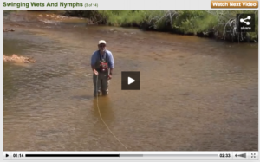
This screenshot is from Orvis and a video that covers the basics.

Typicallly you are casting downstream and across at about a 45 degree angle to the current. Look for riffle type habitat that has a uniform current and isn’t too deep.
Take a look at this short video that describes the swing: swinging wet flies
You can see from the video how effortless casting a wet fly is with this technique. If you use heavier streamer type flies things will get a little more challenging. But, when starting out just use soft hackeled type flies (see below).
This is a great way to cover water when you aren’t sure exactly where the fish are holding. See the Technique below for further clarification.

The Technique – Wet Fly Swing
The wet fly swing is exactly what it sounds like. Swinging your fly across the water in a very methodical fashion to cover all of the water.
If you don’t know where the fish are in a run then this is a very effective method.
The Steps to covering a run:
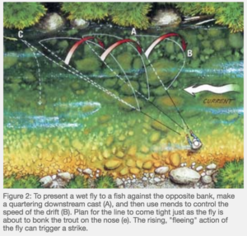
- Start in close to cover the water right out in front of you first. (note: On large rivers, many newbies step right on and over fish heading out towards deeper water).
- For each cast, make it out and downstream and across at about a 45 degree angle. See the photo above at Step A and click here for the article from MidCurrent.
- After you make your cast downstream and across, much of the time you will want to make a mend in the line to decrease the line speed and drag. See the video below. Controlling the speed of the fly is the key to the game so make sure to utilize mending to make sure your fly is presenting naturally to the fish.
4. After making your mend, keep a tight line on the fly as it swings so you feel any touch from a fish.
5. After the current swings the fly line and fly down below you make sure to let the fly dangle for a few seconds. Fish can take the fly on this dangle or hand down so be ready.
6. After a few seconds of the dangle, take a step or two downstream, pickup the line and make a similar cast out at a 45 degree angle.
7. Repeat these steps until you finish the run.
8. See the Tips sections on some other good reminders.
Take a look at Davy Wotton’s summary in this PDF for the teqhnique and a little bit of the history.

The Bugs (aka – entomology)
What is really going on with the wet fly and how is it different than a dry fly or a nymph?
This video describes a little about the mayfly life history. There are a wide range of species and life histories but the important thing to note here is you are imitating that stage just before they get to the surface of the water.
I had to list one other resource from a mentor who is known very well in the west. Here’s Rick Hafele’s bug blog.
One of my favorite books from Rick is Western Hatches. It’s got more worn pages then bibles in Silverton.
Take a look at the flies section below to see some of the common patterns to use while fishing the swing for trout.

Photo: Rick Hafele photo on his website showing his classic style.

The Wet Fly Patterns
The soft hackle flies are pretty much the standard for the wet fly swing. That video shows you one of the all time classic soft hackled flies.
A fly I have really come to love over the years for the wet fly swing is the dark tied down. Take a look at the video:

You can use any of these wet flies when fishing the swing. You don’t have to worry about setting the hook as the fish will do it for you. Just keep your rod tip down and hold on.
Streamers can also be fished on the wet fly swing. Kent at Gink and Gasoline provides a good summary on fishing streamers on the wet fly swing here. if you are able to fish out of a boat an anchor above the deep slot this can prove to be very effective as noted in the post.
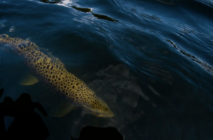
From Gink and Gasoline on Fishing Streamers on the Swing.

Reading the water
Look for areas that appear to have broken water or cover within larger runs but still allow your fly to swing naturally.

7 Rich Tips for the Wet Fly Swing
- Keep your rod tip low and follow your fly across the swing.
- For larger fish use a shock loop.
- Use a double fly setup to improve your odds – Clint does a good job covering it here.
- Add a little flash to flies or a little UV to make them attract – Not a must but purple, pink and hotspots seem to be the thing today so why not try it on your next old school pattern.
- Mend when needed to keep a natural drift – This helps to create a more natural swing
- Let your fly dangle (aka hangle down) – See The Technique section above
- Find the Buckets and stay with them – Once you fish a run and find the pockets where you hooked up, make sure to note those and spend more time on them next time.
- I challenge you to not catch a fish – My final tip is to always challenge yourself. What are you going to try that’s new today?
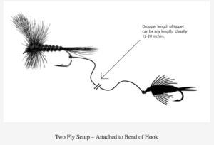
The 2 fly setup from FlyFishingbasics.com

Conclusion for Wet Fly Fishing
As noted in this post and many of the links throughout, the wet fly swing is one of the most effective methods for catching trout especially when you are brand new to fly fishing.
That’s because much of the extra gear, fluff and trash talk is not included. The wet fly swing is an old traditional method which makes it all the better for me.
Have you done your research on the past fishers who put fly fishing on the map. Do you know who paved the way for you to discover it?
Take the time to understand this and you will catch more fish and have a better connection with the sport.
Try to implement just one of my tips on your next trip and let me know how it goes.

